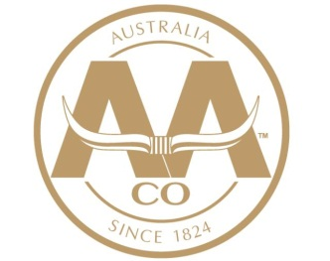

Australian Agricultural Company Limited

Feedmill Leading Hand
Aronui Feedlot, QLD

The Australian Agricultural Company (AACo) is the largest vertically integrated beef cattle producer and marketer in Australia, running over 650,000 head of cattle.

AACo is currently offering an opportunity for a Leading Hand to join the team at Aronui Feedlot which is situated on the Darling Downs, approximately 20 kilometres north of Dalby.
The position offers an excellent opportunity for a career pathway through AACo for future roles with higher levels of responsibility.
We are looking for someone with the following attributes and skills:

- Interested in systems and feed manufacturing
- Interested in intensive livestock feeding
- Milling and grain handling experience an advantage
- Effective leadership and teaching skills
- Natural self-motivation and well organised
- Knowledge of the requirements for teams to work efficiently and safely
- Basic computer skills
- Car Licence
- Machinery tickets an advantage

Progression within the Company is encouraged and professional development will be a part of your career with AACo.

Remuneration package, including on-property housing and other benefits, will be discussed during the interview process.

Join AACo Today? To apply, please submit your application at www.aaco.com.au/people-careers/. To enquire, contact Jamie Raven on aronuifeedmill@aaco.com.au or 07 4662 5200.

