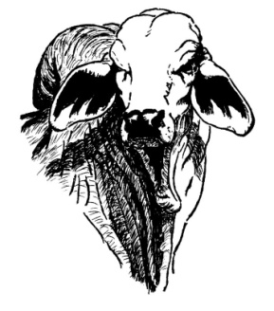

NORTHERN VETERINARY SERVICES

