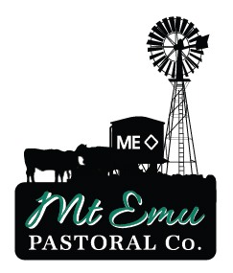

MT EMU PASTORAL CO.
Head Stockman
  - Family owned and operated pastoral company in NW Queensland
  - Mt Emu Plains is our breeding property, 100km north of Hughenden
  - Comprising 58,950h running up to 10,000 head of Brahman cross cattle
We are seeking a highly motivated, experienced, honest and positive Head Stockman who is genuinely enthusiastic to assist the manager and existing staff to conduct work efficiently and effectively at Mt Emu Plains.
Key responsibilities should include
  - Liaising with Station Manager
  - Assisting with mustering, branding, weaning, trucking
  - Recording of stock numbers when required
  - Supervision and continuing training of staff
  - Maintaining and developing facilities and improvements
  - Monitoring pasture and watering points
The successful applicant will have excellent communication skills and experience in handling cattle using Low Stress Stockhandling principles. Also a strong focus on safety in the workplace is essential. Current Licences should include Open and HR and Firearms.
Family accommodation is available with house on property. Part time work for partner can be considered.
No dogs please.
Position to commence early 2018.
Please email a cover letter and resume with 2 recent and contactable referees to mt.emu@activ8.net.au.

